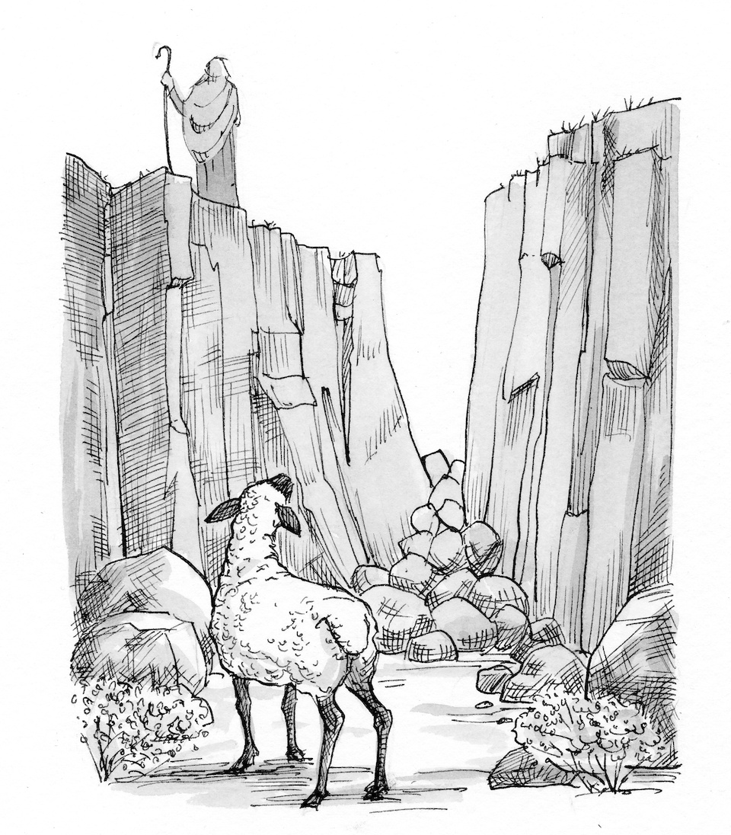

I will seek the lost, and I will bring back the strayed, and I will bind up the injured, and I will strengthen the weak.
14th Sunday after Pentecost

September 15, 2019
Rev. Eric Zacharias, Pastor
Julianne Marcsisak, Organist
14745 Co. Road 153, Cologne MN 55322
www.zion-cologne.org
952-466-3379
EDUCATION FOR LIFE!
Prayer Before Worship
Dear Lord, you are a God who shows mercy and gives abundantly to us, even more than we ask or consider reasonable. You gather us together as your people and you change our lives, with blessings that flow from you, in Jesus name. Amen.

This Week’s Prayer List – remember these in prayer: We pray for a portion of Zion’s family and friends…Joycelyn Rolf; Wallace Rolf; Lila Rolf; Randall Rolf; Kevin Rolf; Alan and Laurie Rowland; and Lois Roufs. We pray for those under the care of a physician, undergoing treatment and therapy; for all difficulties meeting obligations, and a strong faith for every need.

Pizza Party @ the Huinkers has been cancelled because of few rsvps for this opportunity.
Thanks!
The family of Victor Rolf gives thanks to the members of Zion for all the care and concern for our dad during his last months. Zion has been a life-long blessing to him and our entire family.

Thanks to all who dropped off items and contributed items to the school lunch program. This is greatly appreciated. -Betty Meuffels

Thank you to the following people who worked at the food shelf in August: Ruth Harms, Juliene Klaustermeier, Wayne and Betty Klaustermeier, and Karen Brockoff. Also, thank you to Allen and Jean Friske for the vegetables they donated. -Lila Rolf

Screenagers (Wednesday, September 18, 6 pm St. John-NYA) The Parent Education Night at St. John’s features the documentary Screenagers, revealing how “tech time” impacts kids’ development and offering solutions on how adults can help their kids to navigate the digital world to find balance. This event is for all parents of school age children. Light supper will be served. 5th-8th grade students are encouraged to attend with parents, and there will be childcare available for students who are potty trained-4th grade. For more information call 952-448-2526, visit our church website: https://www.stjohnschaska.org/ and click on Bible Studies, or register at tiny.cc/SJSScreenagers.
Opening Hymn # 710 “The Lord’s My Shepherd, I’ll Not Want”

P In the Name of the Father † Son † Holy Spirit.
C Amen.

Confession and Absolution Psalm 51:1-10
P Have mercy on me, O God, in your enduring goodness;
C According to the fulness of your compassion blot out my offenses.
P Wash me thoroughly from my wickedness;
C Cleanse me from my sin.
P For I acknowledge my rebellion and my sin is ever before me.
C Against you only have I sinned and done what is evil in your eyes,
P So you will be just in your sentence and blameless in your judging.
C Surely in wickedness I was brought to birth and in sin my mother conceived me.
P O you that desire truth in the inward parts;
C Teach me wisdom in the secret places of the heart.
P Purge me with hyssop, and I shall be clean;
C Wash me, and I shall be whiter than snow.
P Make me hear of joy and gladness;
C Let the bones which you have broken rejoice.
P Hide your face from my sins;
C And blot out all my iniquities.
P Create in me a clean heart, O God;
C And renew a right spirit within me.

We reflect upon God's Word and promise

P O almighty God, merciful Father,
A I, a poor, miserable sinner, confess unto you all my sins and iniquities with which I have ever offended you and justly deserved your temporal and eternal punishment. But I am heartily sorry for them and sincerely repent of them, and I ask you of your boundless mercy and for the sake of the holy, innocent, bitter sufferings and death of your beloved Son, Jesus Christ, to be gracious and merciful to me, a poor, sinful being. Amen.
Chief of sinners though I be, Jesus shed His blood for me,
Died that I might live on high, Lives that I might never die.
As the branch is to the vine, I am His, and He is mine.

P As a called and ordained servant of Christ, and by His authority, I proclaim that your sins are forgiven, in the Name of the Father and of the Son and of the Holy Spirit.
C Amen.

Oh, the height of Jesus' love, Higher than the heav'ns above,
Deeper than the depths of sea, Lasting as eternity!
Love that found me--wondrous thought!
Found me when I sought Him not.

Collect for the Day
A Lord Jesus, You are the Good Shepherd, without whom nothing is secure. Rescue and preserve us that we may not be lost forever but follow You, rejoicing in the way that leads to eternal life; for You live and reigns with the Father that the Holy Spirit, one God, now and forever. Amen.

Old Testament Reading Ezekiel 34:11–24
Like a shepherd, the Lord God will gather his people.
R This is the word of the Lord. C Thanks be to God.

Only Jesus can impart Balm to heal the wounded heart,
Peace that flows from sin forgiv'n, Joy that lifts the soul to heav'n,
Faith and hope to walk with God In the way that Enoch trod.

Epistle Reading 1 Timothy 1:12-17
Grace, mercy, and peace from God our Father.
R This is the Word of the Lord. C Thanks be to God.

Chief of sinners though I be, Christ is all in all to me;
All my wants to Him are known, All my sorrows are His own.
He sustains the hidden life Safe with Him from earthly strife.

P The Gospel of our Lord, Luke 15. C Praise to you, O Lord!

Gospel Reading Luke 15:1-10
Parable of the lost sheep and lost coin.
P This is the Gospel of our Lord. C Praise to you, O Christ!

O my Savior, help afford By Your Spirit and Your Word!
When my wayward heart would stray, Keep me in the narrow way;
Grace in time of need supply While I live and when I die.

Children’s Message
Sunday School to follow in Mr. M’s room

Sermon Hymn # 744 “Amazing Grace”
Amazing grace--how sweet the sound--
That saved a wretch like me!
I once was lost but now am found,
Was blind but now I see!

The Lord has promised good to me,
His Word my hope secures;
He will my shield and portion be
As long as life endures.

Through many dangers, toils, and snares
I have already come;
His grace has brought me safe so far,
His grace will see me home.

Yes, when this flesh and heart shall fail
And mortal life shall cease,
Amazing grace shall then prevail
In heaven's joy and peace.

When we've been there ten thousand years,
Bright shining as the sun,
We've no less days to sing God's praise
Than when we'd first begun.

Sermon Lord, Have Mercy! 1 Timothy 1:16-17 The Lord is faithful and has mercy on us, in Jesus’ Name.
Offering
Prayers and the Lord’s Prayer

Exhortation of faith 1 Timothy 1:5, 14-17
P The goal of our faith is love that issues from a pure heart and a good conscience and a sincere faith.
C The grace of our Lord overflowed for me with the faith and love that are in Christ Jesus.
P The saying is trustworthy and deserving of full acceptance:
C Christ Jesus came into the world to save sinners, of whom I am the foremost.
P But God gives mercy for this reason,
C That in me, Jesus Christ might display his perfect patience as an example to those who were to believe in him for eternal life.
P To the King of the ages, immortal, invisible, the only God, be honor and glory forever and ever.
C Amen!
P The Lord bless you † shine upon you † give you peace.
C Amen!

Closing Hymn # 622 “Praise to You and Adoration”
Praise to You and adoration, Blessed
Guide me that I never may From Your fold or pastures stray,
But with zeal and joy exceeding
Follow where Your steps are leading.

Hold me ever in Your keeping; Comfort me in pain and strife.
In my laughter and my weeping Be with me throughout my life.
Give me greater love for You, And my faith and hope renew
In Your birth, Your life, and passion,
In Your death and resurrection.

Finances
Salary:
Beginning Balance (1/1/2019) -$59,468.86
YTD Income $236,628.58
YTD Expenses -$271,487.50
Current Balance (9/3) -$94, 327.78
Current Loan Amount $93,449.00

Missions:
YTD Total (5/31) $2,185.00
Budgeted $1,495.00
Unbudgeted $690.00
2019 Pledged $7,500.00
2019 Goal $15,000.00

LHS:
Year to date total (5/31) $6,482.66
2019 Commitment $22,715.00
Per communicant member $55.00

Building/Repair Fund:
Account Balance (7/18) $78,748.21
Suggested household contrib. $550.00

Change of residence:
Arnold & Barb Scholz to The Harbor, from Oak Grove, NYA.
Donald Herrmann to The Harbor, from the Crossings, in Waconia.
Harold Bruesehoff to Good Samaritan, from The Harbor, NYA.

LWML FALL BARBECUE: Sunday October 6th, 10:30-1pm Emanuel Lutheran Women Missionary League will host a regular 9 AM worship with liturgy and hymns in honor of all the Missionary work LWML groups do here in the U.S. and around the World.

Casserole & Salad Luncheon at Redeemer Lutheran – Henderson Saturday, September 28th from 11 AM to 1, including a general store and silent auction. See flyer for more info.

September 15th – September 21st
Sunday, 15th Sunday Service | 9:30 AM
Tuesday, 17th Evangelism Meeting | 7:30 PM
Wednesday, 18th Confirmation | 6:15 PM
Friday, 20th Chapel | 8:10 AM

September 22nd – September 28th
Sunday, 22nd Sunday Service | 9:30 AM
Friday, 27th Chapel | 8:10 AM
Salt Orders Delivered

This Week’s Reader Tom Marcsisak
Next Week’s Reader Jon Henschen

Agnus Day Luke 15:1-10

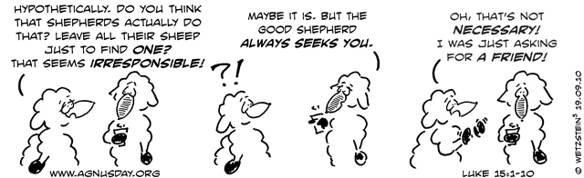

Agnus Day 1 Timothy 1:12-17
Office office@zion-cologne.org
Pastor revez123@juno.com

